CareSys Agency Owner User Guide
  - From Account Creation to Subscription
29 October 2026 | Version 1.0
Use this guide if you are registering a care agency and will manage its subscription. In this guide, an agent means the agency owner. You first create a personal login, then register the agency, save a card, choose modules and receive an invoice. Your personal account remains separate from each agency workspace.

Your onboarding route
1. Create a personal account or sign in to your existing account.
2. Register your agency and review its contact details.
3. Check the notification menu for the platform administrator’s verification decision.
4. Save a card securely through Stripe and confirm the result in CareSys.
5. Choose your package, worker coverage and modules, then request an invoice.
6. Open your agency workspace and use the modules available to your role.

Before you begin
- Have an email address you can access and choose a strong password.
- Prepare the agency legal name, country, official email, currency and timezone.
- Have any optional business registration number, phone numbers and postal address ready.
- Know how many active workers the subscription must cover.
The standard trial is 30 days. The platform administrator can change the free-day policy; use the trial dates shown in your account. No subscription charge is collected during the trial. After expiry, agency access locks until an owner approves and completes payment.
Screenshots show fictional demonstration details. Example names may differ between pages. Some screenshots use isolated test records; the Stripe card-form example was supplied during testing. Never copy an example name, email or card into a live registration.

1 Create your personal login
1. Open CareSys and choose Create a personal account from the sign-in page.
2. Enter an account name and your personal login email. Use an account name of 3 to 30 characters with letters, numbers or dots.
3. Create a strong password and repeat it exactly. Avoid using your account name, email or other personal information in the password.
4. Select Create personal account. Correct any message displayed above the form.
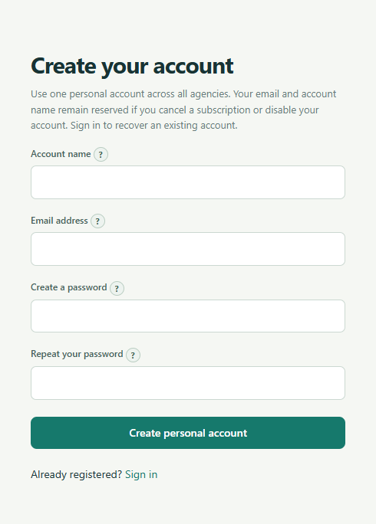
Figure 1 Personal account registration form.
One person needs one personal account, even when working with several agencies. Email addresses and account names remain reserved when an account is disabled, closed or a subscription is cancelled. If yours is already registered, sign in or contact support to restore access.

2 Sign in and choose the right workspace
1. If you already have an account, open the sign-in page and enter your login email and password.
2. Select Sign in. If you have just registered successfully, you may already be signed in.
3. Use the Workspace selector on the left to switch between Personal account and your agency.
4. To register a new agency, choose Personal account, then Register an agency in the navigation menu.
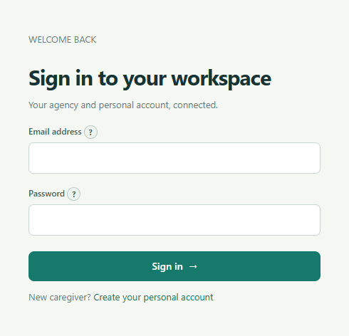
Figure 2 Sign in with your personal login email.
Your login email identifies you. The official agency email on the registration form is for invoices and correspondence; it does not create another login. Colleagues should create their own personal accounts rather than share your password.
In the local test installation used for these screenshots, the sign-in address is https://localhost:8444/login. In a deployed installation, use the CareSys address supplied by your administrator.

3 Enter your agency details
1. Open Register an agency under Personal account.
2. Enter the Agency legal name and select Country first. The country controls phone guidance and address fields.
3. Enter the Official email address used for agency correspondence.
4. Enter a Business registration number if available. This field is optional.
5. Check Currency and IANA timezone. Choose the timezone that matches agency operations.
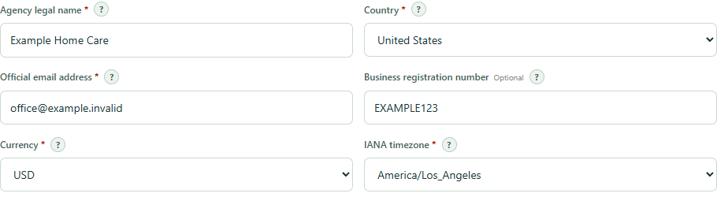
Figure 3 Required agency details are marked with an asterisk.

Understand required fields
An asterisk means the field is required. Optional phone and address sections remain hidden until you choose to add them. Once you enable an optional section, its starred fields must be completed or the section must be switched off.

Keep billing details accurate
Agency contact and address details can appear on invoices and correspondence. Check spelling, country, timezone and currency before submitting. Shared official email addresses, phone numbers and addresses are allowed for branches or colleagues. These details do not give anyone access to agency records.

4 Add phone numbers and an optional address
1. Select Add a business number if you want it recorded. Enter a valid number; follow the country-code example shown.
2. If the same number is also your mobile or contact number, tick the matching boxes. If the numbers differ, use the separate mobile and contact options.
3. Select Enter agency address only if you want an address on invoices and correspondence. Complete the fields required for the selected country.
4. Review all information, then select Register agency once.
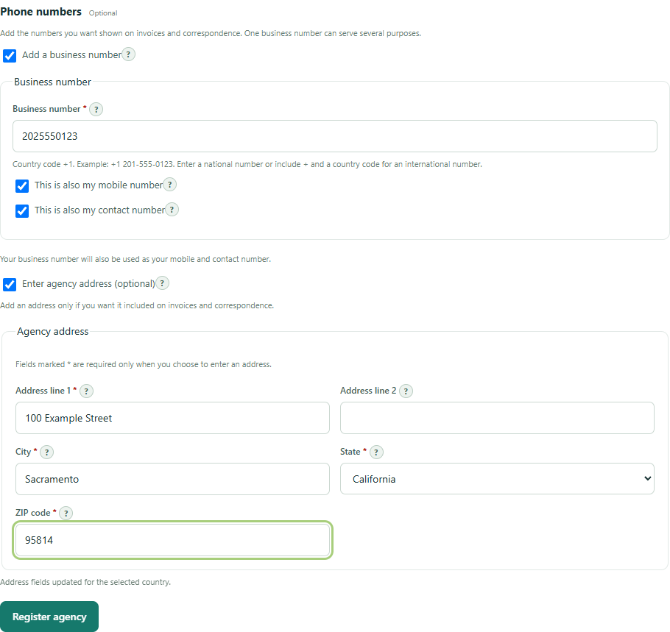
Figure 4 Optional phone and address sections with fictional US details.
Address labels vary by country. You may see State or Province and ZIP code or Postal code. Do not enter a US-style address merely because the example uses one.

5 Check registration and approval notifications
After registration, CareSys opens the subscription page. The platform administrator receives a notification to review the agency. The owner receives confirmation that registration is awaiting verification.
1. Open the bell or Notifications menu at the top right.
2. Read the agency registration message. Select View all notifications to review the full history.
3. Wait for the platform administrator to review the agency. A verified and approved message confirms approval.
4. If the agency is rejected or suspended, read the review note and contact the platform administrator. Do not create duplicate personal accounts to work around the decision.
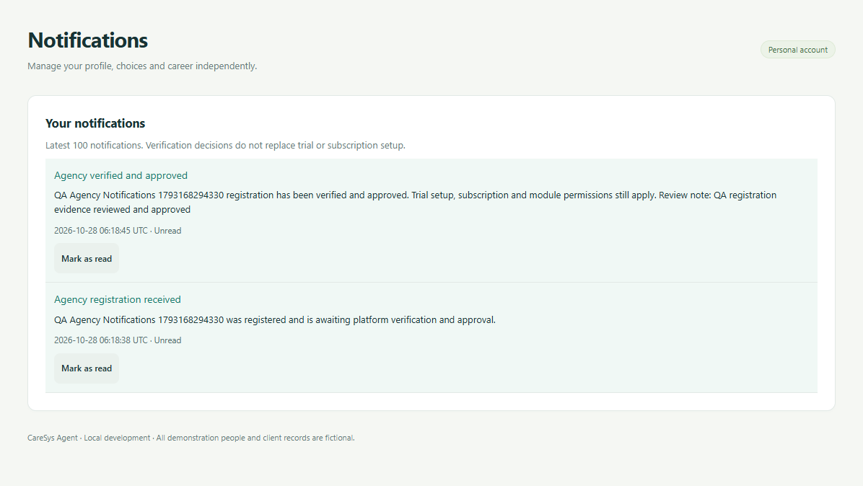
Figure 5 Example of a verified and approved owner notification.
Agency approval and subscription activation are separate. Approval alone does not save a card or start a free trial. Recruitment and consented career-history access require verification as well as the appropriate subscription, role and permissions.
Older notifications stay in the history. Always read the latest decision. Marking a notification as read changes the unread count; it does not approve the agency or activate the subscription.

6 Save a card securely with Stripe
1. In the agency workspace, open Subscription and trial from the left menu.
2. Read the free-trial terms. Tick the consent box agreeing to save your card and requiring your approval for later payment.
3. Select Continue to secure card setup. CareSys sends you to Stripe’s hosted page.
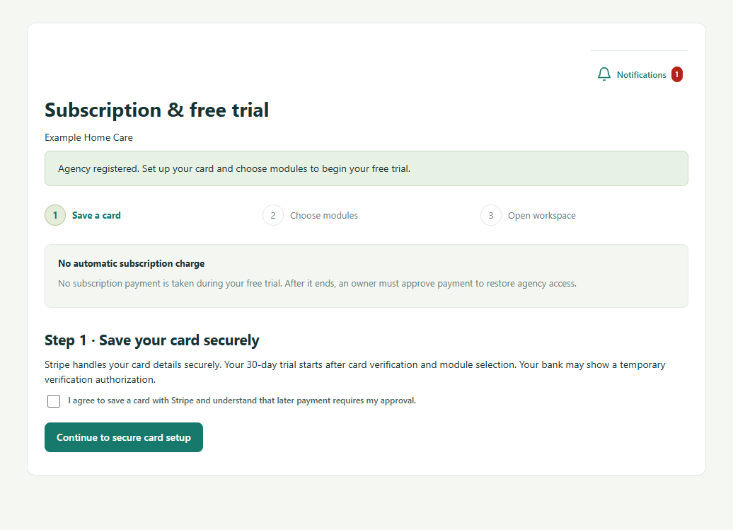
Figure 6 Card setup before the free trial starts.
Stripe handles the card details. No subscription charge is collected during the free trial. Your bank may show a temporary card-verification authorization. The trial starts only after card verification and module selection.
If the page says card setup is awaiting configuration, contact the platform administrator. Repeated clicks will not enable Stripe. Local simulation is a development tool and is not part of the normal customer workflow.

7 Complete the Stripe card form
1. Enter your email, card information, cardholder name and the billing country and postal details requested by Stripe.
2. Saving information with Link is optional. If you do not want to use Link, uncheck that option.
3. Use the save or setup button shown by Stripe. After completion, Stripe returns you to CareSys.
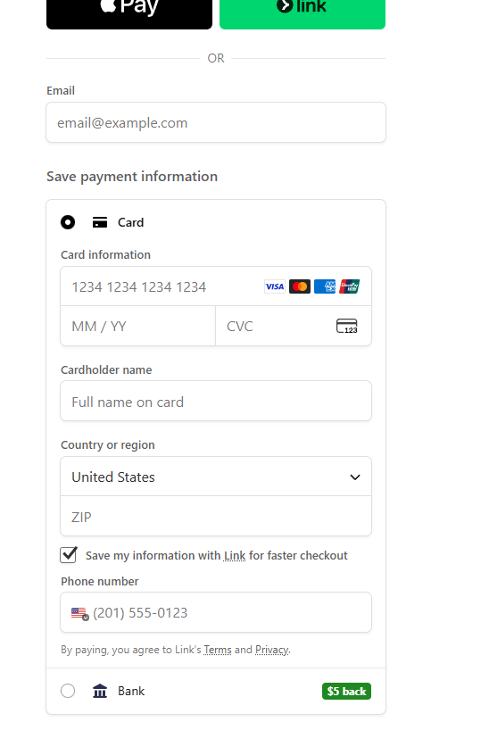
Figure 7 Example Stripe card-entry screen. Wallet and Link options can vary.
Sandbox testing only: when your administrator confirms you are using Stripe test mode, you can use 4242 4242 4242 4242, a future expiry such as 12/34 and CVC 123. Use fictional billing details for that test. Never use this test card in production, and never enter a real card in a sandbox.

8 Confirm the saved card in CareSys
When Stripe returns you to CareSys, the page gives you one next action. You do not need to enter your card again.
1. Select Confirm saved card. CareSys checks the completed setup directly with Stripe.
2. Wait for the confirmation response. Once verified, the module-selection step becomes available.
3. If confirmation fails, do not start another card setup immediately. Read the message, refresh if needed and contact the administrator if the issue continues.
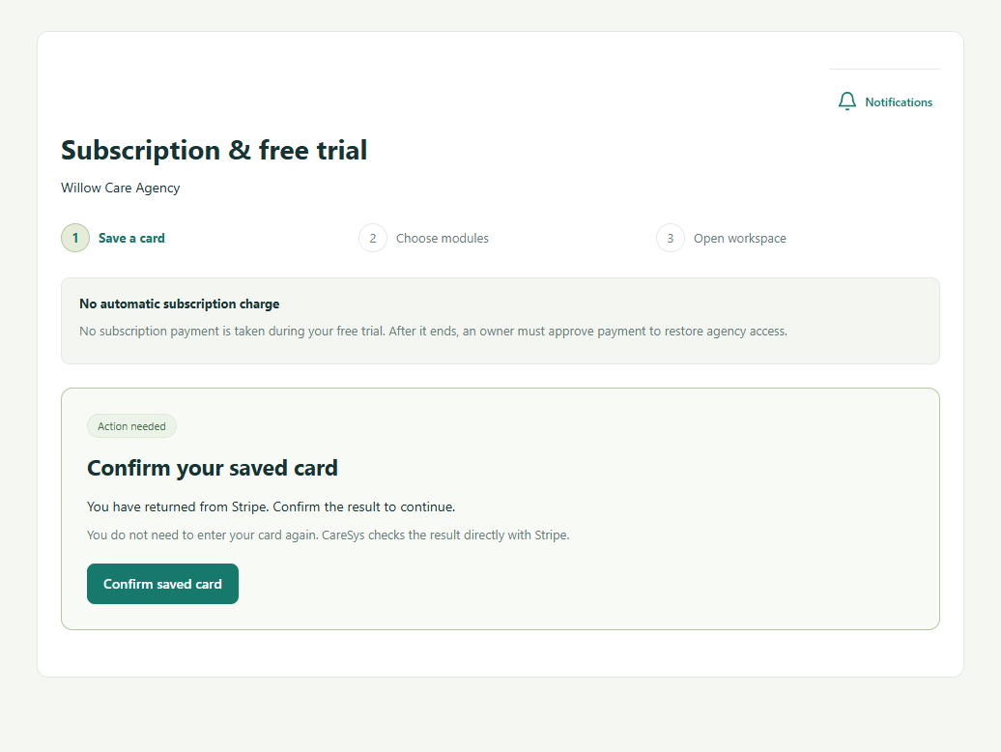
Figure 8 Confirm saved card is the next step after returning from Stripe.
The return address alone does not prove the setup succeeded. Agency access remains unchanged until CareSys verifies the result. If verification has already completed, the page moves on to package selection instead of showing this button.

9 Choose a package and worker coverage
Starter is the default for a new quote. Selecting another package checks its included modules and updates Active workers to cover. Check the selections before requesting an invoice.
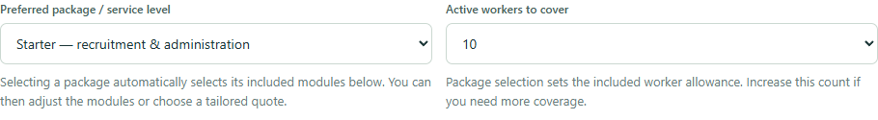
Figure 9 Package and worker selectors appear above the module list.
Package | Base USD per month | Included workers
Starter | 59.00 | 10
Operations | 129.00 | 30
Growth | 249.00 | 75
Tailored quote | Custom base 29.00 plus selected paid modules | 10

Catalog values shown here reflect 29 October 2026. The invoice is the record of your actual selection and pricing. Additional workers currently cost USD 3 per month above the chosen plan allowance; tax is confirmed at checkout.
- Starter includes Recruitment and applications, Offers and joining, and People administration.
- Operations adds Scheduling and visits, Time and attendance, Leave management, and Care notes and incidents to Starter.
- Growth includes all 13 listed modules.
- A tailored quote lets you choose the modules you need. Switching to it keeps your current selections.
Increase worker coverage if you need more people than the included allowance. CareSys checks that coverage is at least the number of active workers. Changing to another package replaces the module selection and resets coverage to the package allowance or the higher active-worker count.

10 Review modules and request the invoice
1. Read the description beside each module. Tick the modules you need and untick optional choices you do not need.
2. Check the monthly estimate and worker coverage. Required dependencies may be added automatically.
3. Select Request subscription quote. An invoice is issued immediately; this action does not collect a payment.
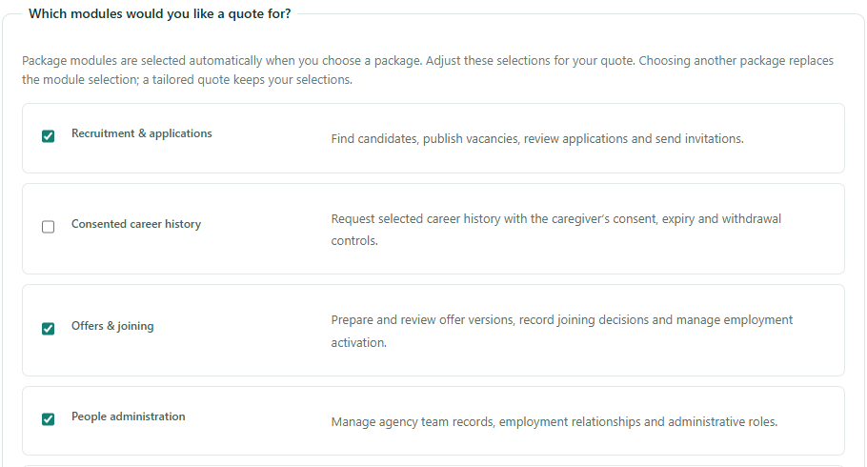
Figure 10 Starter modules selected with descriptions beside each option.
The estimate compares packages with add-ons and custom pricing to choose the lowest calculated total. Your preferred package breaks ties, so the final pricing arrangement may differ from the package you initially selected. Review the invoice for the effective module list, dependencies, worker count and amount.
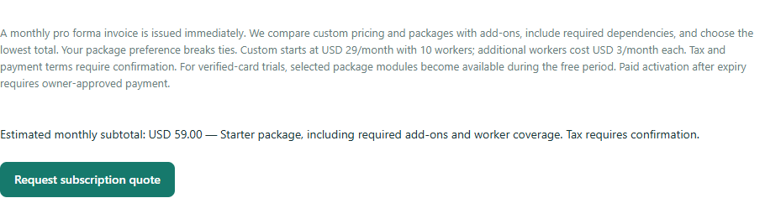
Figure 11 Review the estimate and request the subscription quote.
Once card verification and module selection are complete, the free trial begins. Adding or changing a quote later does not restart the trial.

11 Download and review your invoice
1. Find Your invoices on the subscription page.
2. Select Download PDF beside the invoice you want. Save it to your device.
3. Check the agency details, worker coverage, module descriptions, monthly amount and trial terms. Contact the administrator if any details are wrong.
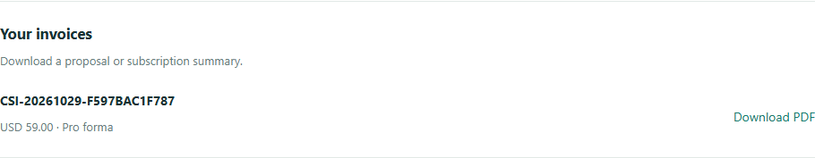
Figure 12 Download the invoice from Your invoices.
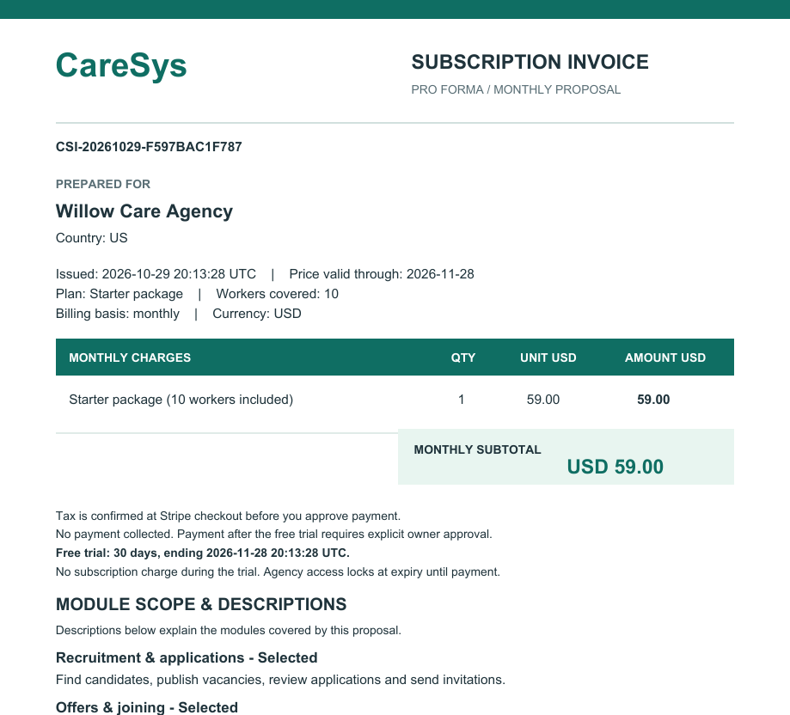
Figure 13 Upper portion of an example invoice with fictional agency details.
An issued pro forma invoice is a proposal, not proof of payment or a tax invoice. Its prices are snapshotted for the stated validity period. A document marked TEST ONLY is for development testing and is not a real payment receipt.

12 Enter the agency workspace
When your trial is active, the main action becomes Open agency workspace. Your trial end date appears on the subscription page.
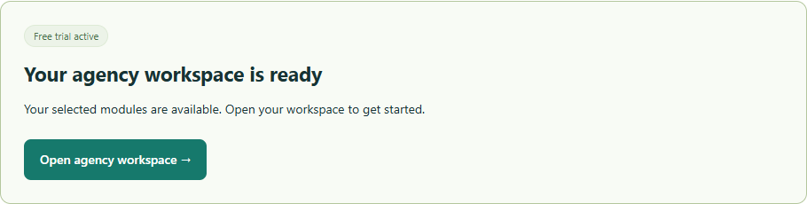
Figure 14 The workspace becomes the main action during an active trial.
1. Select Open agency workspace.
2. Use the left menu to open modules available to your role and subscription.
3. Use the Workspace selector to confirm you are in the right agency before adding records.
4. Return to Subscription and trial to download invoices or expand Change package modules or worker count when you need a new quote.

Invite colleagues without sharing your login
Each colleague registers a personal account first. The agency owner can assign an appropriate administrative role in Agency settings. Caregiver membership follows the employment and joining workflow. A caregiver can keep one personal account while working for more than one agency; each agency’s records and permissions remain separate.

Access depends on more than a payment
Module visibility follows the subscription, role and agency permissions. Recruitment and history checks also depend on verification. A subscription does not grant access to another agency’s records or bypass caregiver consent. If an expected module is missing, check the package and your role before contacting the administrator.

13 Approve payment after the trial
When the trial ends, agency access locks. The owner sees the payment action; other agency users see a locked-account notice and must contact the owner. No automatic subscription charge is made.
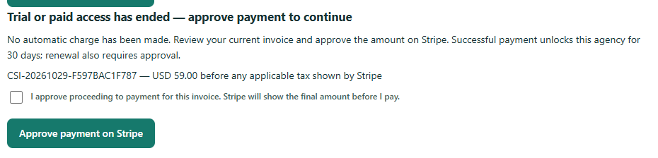
Figure 15 Owner payment approval after trial or paid access ends.
1. Open Subscription and trial and review the current invoice. If it is missing or expired, choose modules and request a fresh invoice.
2. Tick the payment-approval checkbox and select Approve payment on Stripe.
3. Check the final amount, including any applicable tax, on Stripe and complete payment.
4. Return to CareSys. If Confirm payment result is shown, select it. Successful verification restores agency access for 30 days. Future renewal also requires approval.

If you cannot continue
- Email or account name already registered: use the existing account or ask support to restore access. Cancelling a subscription does not release your identity.
- Card setup unavailable: ask the platform administrator to check Stripe configuration.
- Returned from Stripe but no module form: confirm the saved card first. A cancelled or incomplete setup cannot activate the trial.
- Agency locked: the owner must review billing; staff cannot approve payment. For a rejected or suspended agency, contact the platform administrator.
- Changes not visible: refresh the page and check the workspace selector. If the issue remains, report the page, time and error text without sending passwords or card details.
You are finished when the agency is verified as required, the card is confirmed, an invoice exists for the chosen modules, and the workspace opens with the expected access.

